Table of Contents

1 INTRODUCTION 2

1.1 General Information about Project 2

1.2 General Layout of Project 4

2 DESIGN CRITERIA 6

2.1 Design Codes 6

2.2 Material Properties 7

2.2.1 Steel Properties 7

2.2.2 Structural Connection Materials 8

2.2.3 Concrete Properties 9

2.3 Load Definitions 10

2.4 Load Combinations 13

3 PRELIMINARY DESIGN DETAILS 14

3.1 Roof Design 14

3.1.1 Truss Design 15

3.1.2 Purlin Design 17

3.2 Slab Design and Alternatives 18

3.2.1 Beam Slab System 18

3.2.2 Beam Design for Beam Slab System 23

3.2.3 Precast Slab System 25

3.2.4 Beam Design for Precast Slab System 29

3.3 Column Design and Locations 30

3.3.1 Design of columns on the ground floor 30

3.3.2 Design of first floor columns 32

3.4 Geotechnical Design 36

3.5 Site Investigation and Idealized Soil Profile 36

3.6 Foundation Type and Characteristics 44

3.7 Bearing Capacity 47

3.7.1 Calculation of Net Foundation Pressure 48

3.8 Settlement of Continuous Foundation 49

3.8.1 Immediate Settlement 49

3.8.2 Consolidation Settlement 51

4 Cost Estimation 53

5 REFERENCES 54

APPENDICES 55

**MARMARAY FENERYOLU STATION**

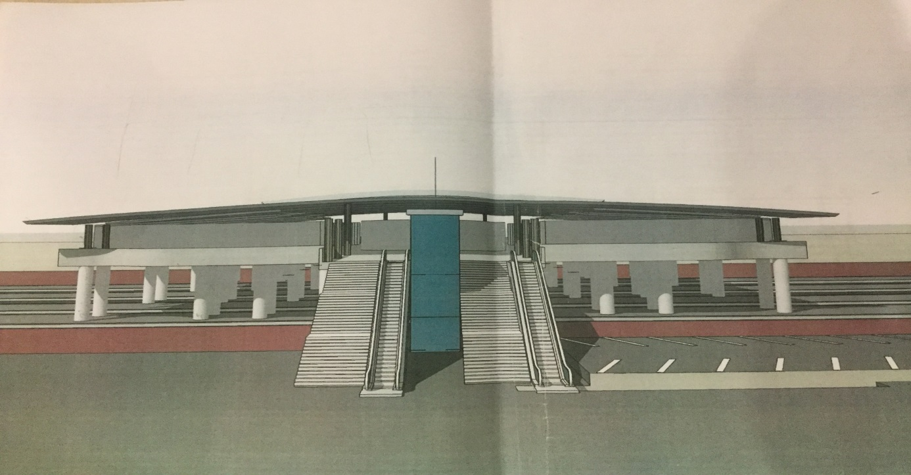

# INTRODUCTION

## General Information about Project

Marmaray is a transportation line which starts in Halkalı/ Istanbul (European side) ends in Tersane/Istanbul (Anatolian side) by passing under Marmara Sea. Total length of line of communications is 76.6 km. Totally 37 surface stations and 3 underground stations will be constructed. After completion of the project, the aim is 1.5 million passengers per day, and approximately 75000 passengers / hour are expected. In this report, design details of Feneryolu Station which is in the Anatolian Side of Istanbul are given.

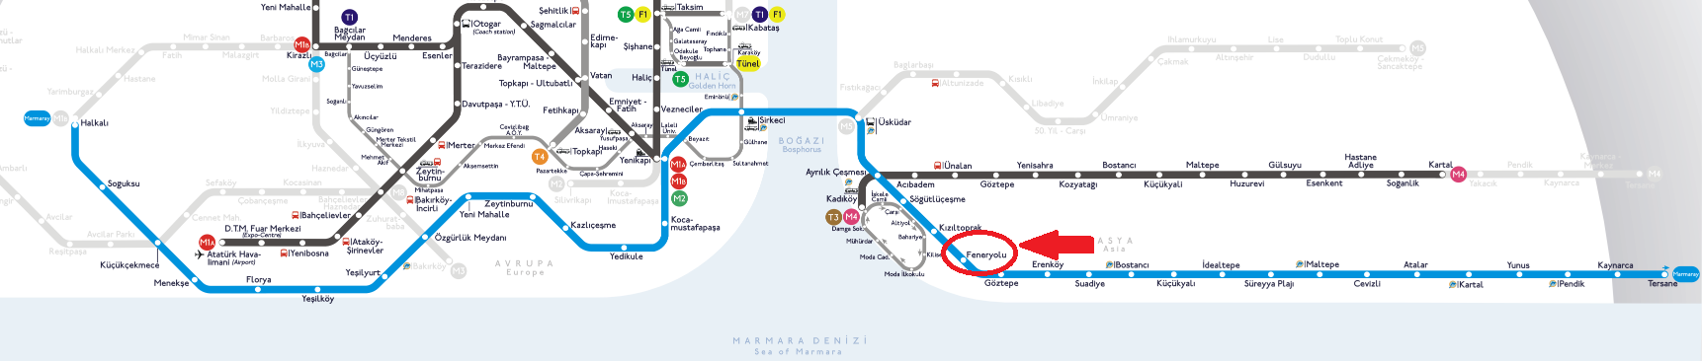

Figure 1: Map of the line of communications of Marmaray

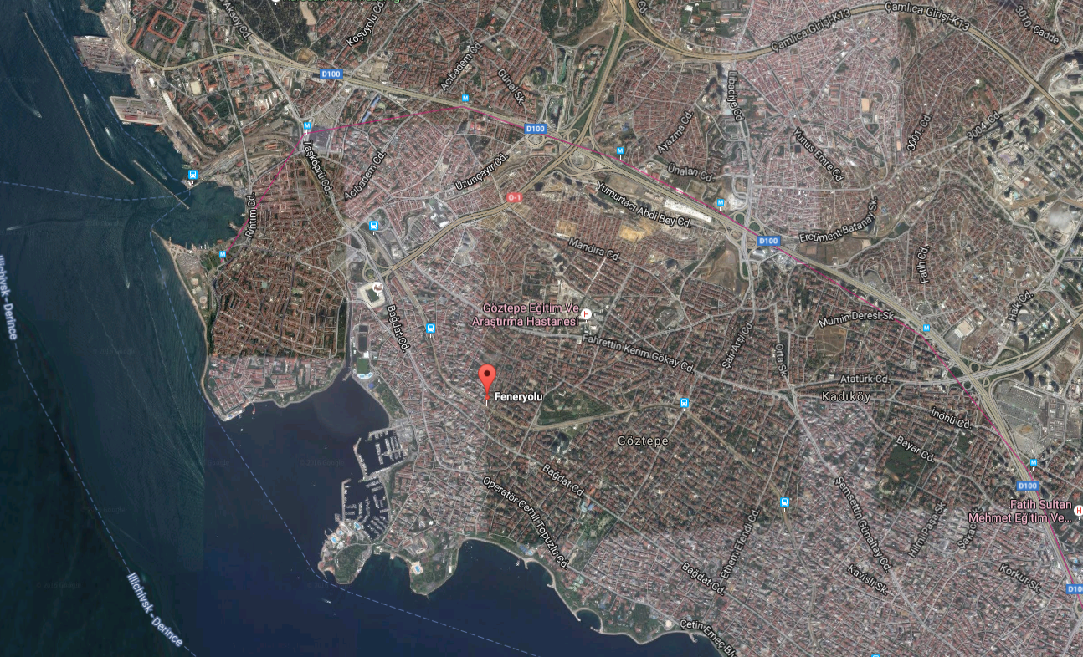

Figure 2: Map of the expected place of Feneryolu Station

Since station is in Istanbul, the following data is taken from Turkish State Meteorological Service Report for Istanbul:

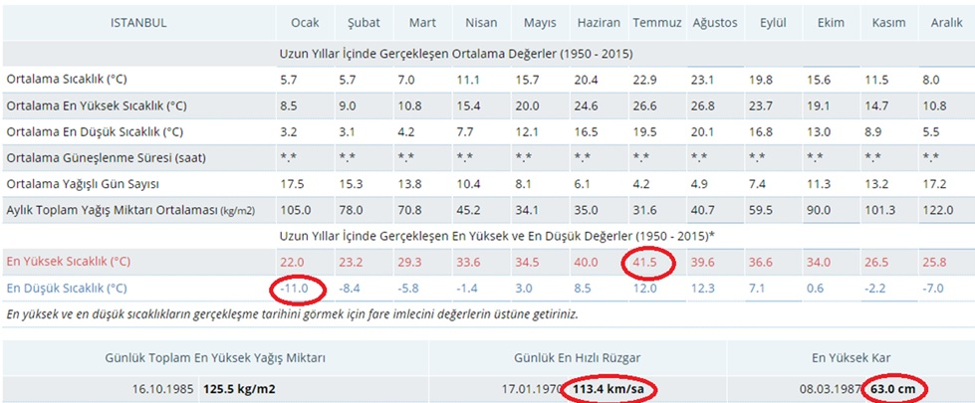

Figure 3: General weather condition and critical values in Istanbul

The critical values which are marked with red circles:

The highest temperature: 41.50C (in July)

The lowest temperature: -11.50C (in January)

The deepest depth of snow: 63 cm

The fastest wind in a day: 113.4 km/hour

## General Layout of Project



Figure 4: 3D View of the Structure

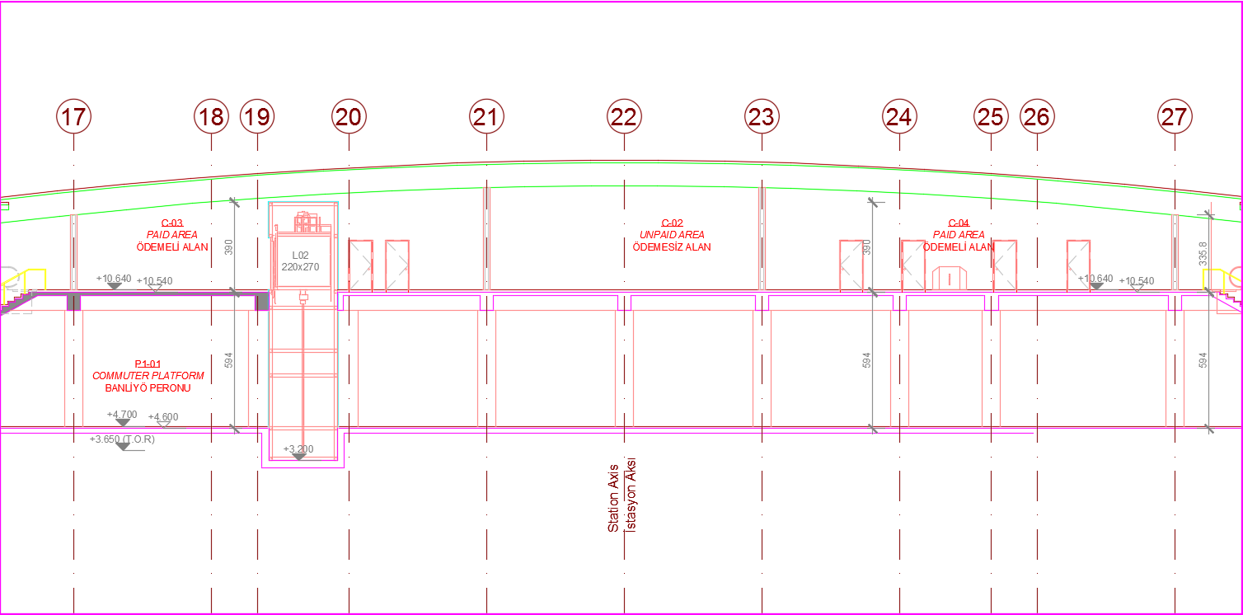

Figure 5: Front view section

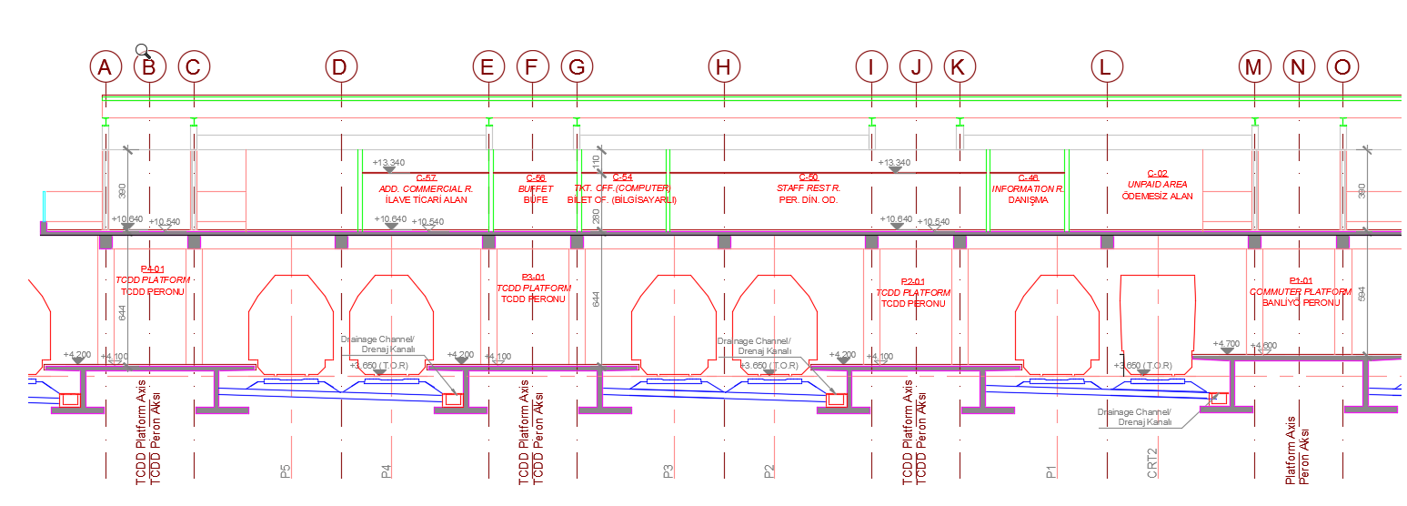

Figure 6: Side view section

There are 4 platforms 9.06*59.8 is dimension of one platform where columns are directly on the platforms. Above platforms there are 72 columns which are connected to slab of the concourse structure. Above concourse structure there are 32 columns. Area of the ground floor is 2167 m2, area of the concourse structure (slab area) is 3308 m2. Height of ground floor is 5.94 m and height of first floor in the middle 4.5 m, whereas in the edge it is 2.9 m.

# DESIGN CRITERIA

## Design Codes

The design of the structure will be carried out in accordance with the relevant Turkish standards for loading, member design, connection design etc.

The following standards shown in table-1 will be used in structural design. The international codes or related technical references may be used in structural analysis and design if necessary.

Table 1: Relevant Turkish Design Codes

|  |  |
| --- | --- |
| **DISCIPLINE** | **STANDARDS** |
| **GENERAL** | * TS-TURKISH STANDARDS |
| **LOADING** | * TS498-DESIGN LOADS FOR BUILDING * TSC2007-TURKISH SEISMIC CODE * TURKISH STATE METEOROLOGICAL SERVICE DATA FOR TEMPERATURE LOADING |
| **CONCRETE DESIGN** | * TS500-REQUIREMENTS FOR DESIGN AND CONSTRUCTION OF REINFORCED CONCRETE STRUCTURES * TSC2007-TURKISH SEISMIC CODE |
| **STEEL DESIGN** | * DESIGN AND CONSTRUCTION SPECIFICATIONS FOR STEEL STRUCTURES by MINISTIRY OF ENVIORENMENT AND URBAN PLANNING (September, 2016) |

## Material Properties

### Steel Properties

S275 steel members will be used in steel design and S355 gusset plates will be used in connecting the steel members. Steel member grades are illustrated in table-2&3.

* Modulus of Elasticity (E)= 200 GPa
* Shear Modulus (G)=81 GPa
* Poisson’s Ratio in Elastic Range (v)= 0.3
* Coefficient of Linear Thermal Expansion (α)=1.17*10-5

Table 2: Nominal Values of Yield Strength fy and Ultimate Tensile Strength fu for Hot Rolled Structural Steel

|  |  |  |  |  |
| --- | --- | --- | --- | --- |
| Standard and Steel Grade | Nominal Thickness of the Element t [mm] | | | |
| t ≤ 40mm | | 40mm < t ≤ 80mm | |
| Fy(N/mm2) | Fu(N/mm2) | Fy(N/mm2) | Fu(N/mm2) |
| **EN 10025-2**  S235  S275  S355  S450 | 235  275  355  450 | 360  430  510  550 | 215  255  355  410 | 360  410  470  550 |
| **EN 10025-3**  S275 N/NL  S355 N/NL  S420 N/NL  S460 N/NL | 275  355  420  460 | 390  490  520  540 | 255  355  390  430 | 370  470  520  540 |
| **EN 10025-4**  S275 M/ML  S355 M/ML  S420 M/ML  S460 M/ML | 275  355  420  460 | 370  470  520  540 | 255  335  390  430 | 360  450  500  530 |
| **EN 10025-5**  S235 W  S355 W | 235  355 | 360  510 | 215  355 | 340  490 |
| **EN 10025-6**  S460 Q/QL/QL1 | 460 | 570 | 440 | 550 |

Table 3: (continued) Nominal Values of Yield Strength fy and Ultimate Tensile Strength fu for Hot Rolled Structural Steel

|  |  |  |  |  |
| --- | --- | --- | --- | --- |
| Standard and Steel Grade | Nominal Thickness of the Element t [mm] | | | |
| t ≤ 40mm | | 40mm < t ≤ 80mm | |
| Fy(N/mm2) | Fu(N/mm2) | Fy(N/mm2) | Fu(N/mm2) |
| **EN 100210-1**  S235 H  S275 H  S355 H  S275 NH/NLH  S355 NH/NLH  S420 NH/NLH  S460 NH/NLH | 235  275  355  275  355  420  460 | 360  430  510  390  490  540  560 | 215  255  335  255  335  390  430 | 340  410  490  370  470  520  550 |
| **EN 10019-1**  S235 H  S275 H  S355 H  S275 NH/NLH  S355 NH/NLH  S460 NH/NLH  S275 MH/MLH  S355 MH/MLH  S420 MH/MLH  S460 MH/MLH | 235  275  355  275  355  460  275  355  420  460 | 360  430  510  370  470  550  360  470  500  530 |  |  |

### Structural Connection Materials

#### Bolts

M20 bolts and 8.8 grades will be used in the final connection design which is not considered at this stage.

Table 4: Nominal Values of the Yield Strength fyb and the ultimate tensile strength fub for bolts

|  |  |  |  |  |  |
| --- | --- | --- | --- | --- | --- |
| **Bolt Grade** | 4.6 | 5.6 | 6.8 | 8.8 | 10.9 |
| Fyb (N/mm2) | 240 | 300 | 480 | 640 | 900 |
| Fyu (N/mm2) | 400 | 500 | 600 | 800 | 1000 |

#### Anchor Bars

Material properties of anchor bars will be convenient to the standards in sections 1.2.2 and 1.2.5 in the Design and Construction Specifications for Steel Structures by Ministry of Environment and Urban Planning (September, 2016).

### Concrete Properties

C30 concrete class (see Table-5) and S420a (see Table-6) reinforcing steel is selected as a construction material for reinforced concrete part of the structure.

Table 5: Concrete Classes and 28 Day Strength taken from TS500-2000

|  |  |  |  |  |
| --- | --- | --- | --- | --- |
| Concrete Class | 28-Day Strength (MPa) | | | |
| 150x300 mm Cylinder Compressive Strength  fck | Equivalent Compressive Strength  (150 mm cube) | Uniaxial Tensile Strength  fctk | Modulus of Elasticity Ec28 |
| C16 | 16 | 20 | 1.4 | 27000 |
| C18 | 18 | 22 | 1.5 | 27500 |
| C20 | 20 | 25 | 1.6 | 28000 |
| C25 | 25 | 30 | 1.8 | 30000 |
| C30 | 30 | 37 | 1.9 | 32000 |
| C35 | 35 | 45 | 2.1 | 33000 |
| C40 | 40 | 50 | 2.2 | 34000 |
| C45 | 45 | 55 | 2.3 | 36000 |
| C50 | 50 | 60 | 2.5 | 37000 |

Table 6: Mechanical Properties of Reinforcing Steel taken from TS500-2000

|  |  |  |  |  |  |  |  |
| --- | --- | --- | --- | --- | --- | --- | --- |
| Mechanical Properties | Reinforcing Bars | | | | Welded Wire Mesh | | |
| Hot Rolled | | | Cold Worked | | | |
| S220a | S420a | S500a | S420b | | S500bs | S500bk |
| Minimum Yield Strength, fyk  (MPa) | 220 | 420 | 500 | 420 | | 500 | 500 |
| Maximum Strength, fsu  (MPa) | 340 | 500 | 550 | 550 | | 550 | 550 |
| Minimum Strain Capacity, εsu  Φ≤32 mm | 0.18 | 0.12 | 0.12 | 0.10 | | 0.08 | 0.05 |
| Minimum Strain Capacity, εsu  32< Φ≤32 mm | 0.18 | 0.10 | 0.10 | 0.10 | | 0.08 | 0.05 |

## Load Definitions

Loads acting on the structure are defined as the followings;

G: Dead Load

Q: Live Load

Qr: Roof Live Load

S: Snow Load

W: Wind Load

T: Temperature Load

E: Seismic Load

#### Self-Weight

Self-Weight of the structure comes from the below properties.

Table 7:Self-weight of Structure

|  |  |  |
| --- | --- | --- |
|  | **Thickness(cm)** | **Unit Weight(kN/m3)** |
| Slab | 30 | 25 |
| Mortar | 2 | 16 |
| Plaster | 2 | 15 |
| Marble | 3 | 27 |
| Floor Cover | 3 | 18 |
| Steel Roof | - | 78.5 |

#### Cover Load

According to TS ISO 9194, cover load is chosen as 0.15 kN/m2. Corrugated sheet metal having a 2 mm thickness is selected in order to cover the roof.

#### Live Load

Live loads acting on the structure are taken from TS498

#### Floor Live Load

Floor live load is chosen as 5 kN/m2 from Table-7 in TS498.

There is no description for metro station buildings in TS498, but the structure is considered as a public place and 5 kN/m2 is selected.

#### Roof Live Load

Roof live load is selected as 0.7 kN/m2

#### Snow Load

The structure is in Feneryolu/Istanbul which is in the second snow region according to TS498 Appendix 1 and the region has an altitude less than 200 meters. Thus, snow load acting on the structure is chosen as Pk0=0.75 kN/m2 from Table 4 in TS498.

$P_{k}=m*P_{k0} → m=1-\frac{α-30°}{40°}$

m=1 is selected from Table 3 in TS498 since the roof angle (α) is smaller than 30º. Thus, snow load used in design is calculated as the following;

**Pk=0.75 kN/m2**

#### Wind Load

Wind load is not considered in the preliminary design stage because wind load will mostly affect the connections of the roof.

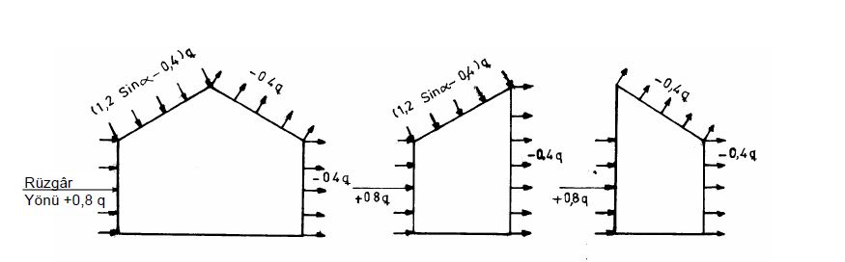

Figure 7: Typical Wind Load Acting on the Structure taken from TS498 (Figure-1)

The structure has a curved roof and the roof has approximately 4º angle with horizontal surface. The wind load on the roof in the windward direction can be calculated by inserting this angle into the equation;

$\left(1.2*\sin{α}-1.4\right)*q=-1.316*q$

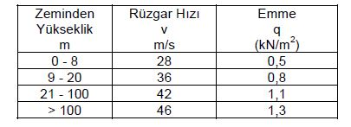

Figure 8: Wind Load Acting on per Meter square According to TS498 (Table-5)

Wind load multiplier q=0.5 kN/m2 will be applied to the structure up to 8 meters from the ground level and q=0.8 kN/m2 will be applied to the structure from 8 meters to the top of the roof.

#### Temperature Load

The highest temperature and the lowest temperature are 41.5ºC (in July) and -11.5ºC (in January) according to Turkish State Meteorological Service and it is assumed that the 20ºC is the base temperature and resulting in temperature change of +21.5 ºC and -31.5 ºC. In the final stage of the analysis, ±21.5 ºC temperature load will be applied to the structure.

#### Seismic Load

In the preliminary design stage, lateral loads are not considered and design of the structure is performed under gravity loads which are dead load, live load and snow load.

## Load Combinations

The design combinations is calculated in accordance with TS500, TSC2007 and Design and Construction Specifications for Steel Structures by Ministry of Environment and Urban Planning (September, 2016). In the design process of the project, Ultimate Strength Design (USD) and Load and Resistance Factor Design (LRFD) are considered in concrete design and steel design, respectively. Required design combinations are tabled in table-3 below.

Table 8: Design Combinations

|  |  |  |
| --- | --- | --- |
| **DISCIPLINE** | **LOAD COMBINATION** | **SOURCES** |
| **CONCRETE DESIGN ULTIMATE STRENGTH DESIGN** | 1.4G+1.6Q | TS500  TSC2007  Design and Construction Specifications for Steel Structures by Ministry of Environment and Urban Planning (September, 2016) |
| 1.0G+1.2Q+1.2T |
| 1.0G+1.3Q+1.3W |
| 0.9G+1.3W |
| **SEISMIC DESIGN** | G+Q±Ex±0.3Ey |
| G+Q±Ey±0.3Ex |
| 1.0G+1.0Q+1.0E |
| 0.9G+1.0E |
| 1.2G+1.0Q+0.2S+1.0E |
| **STEEL DESIGN**  **LOAD AND RESISTANCE FACTOR DESIGN** | 1.4G |
| 1.2G+1.6Q+0.5(Qr or S) |
| 1.2G+1.6(Qr or S) +(Q or 0.8W) |
| 1.2G+1.0Q+0.5(Qr or S) +1.6W |

It is important to note that Load and Resistance Factor Design will be used in steel design and Ultimate Strength Design will be utilized in concrete design.

In LRFD, design will be performed in accordance with equation shown below;

$R_{u}≤Φ*R_{n}$

Ru= required strength using LRFD load combinations

Rn= nominal strength, Φ: resistance factor

* Φ is taken 0.9 in all parts of preliminary design stage.

# PRELIMINARY DESIGN DETAILS

## Roof Design

Roof is created by using truss system in both directions (see Figure-9).

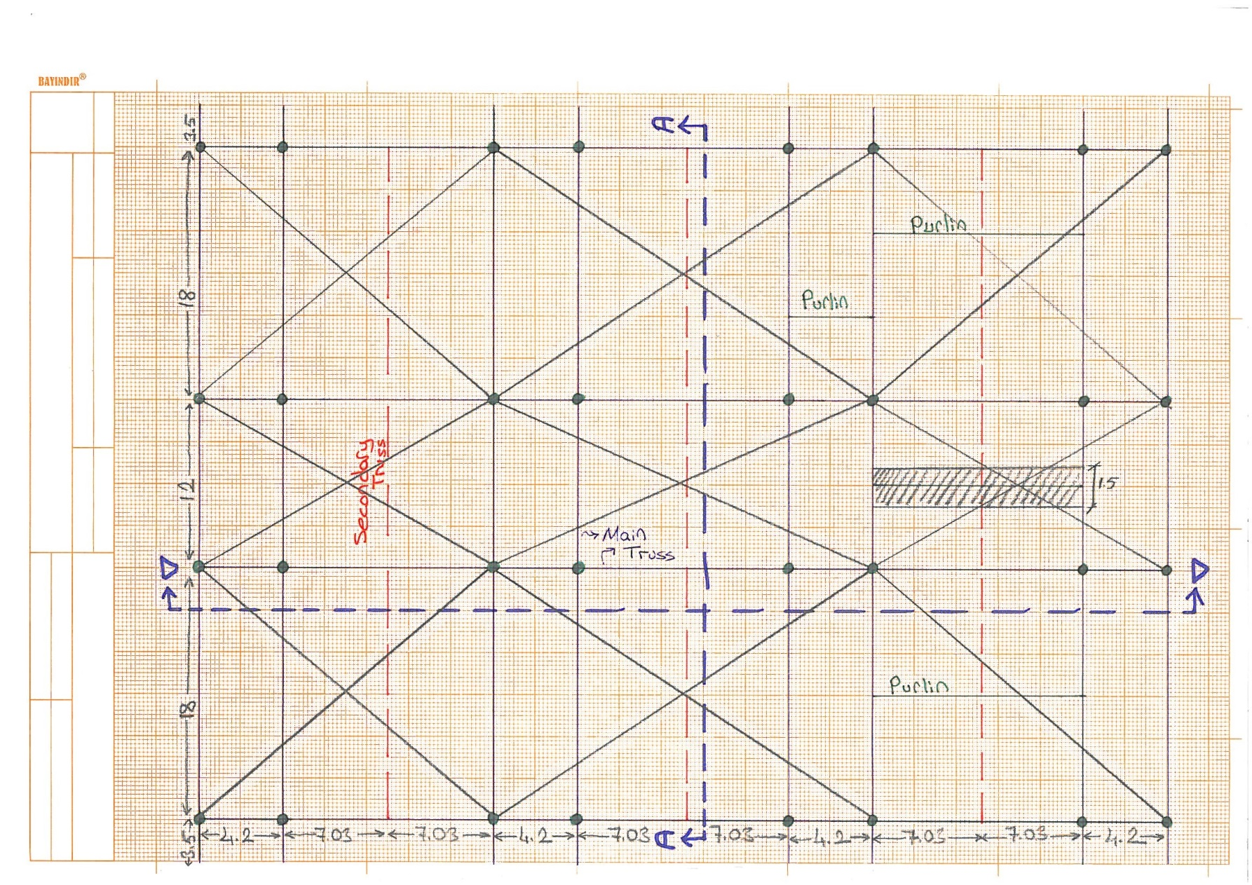

Figure 9: Plan Layout for Roof System

In design of roof, Pratt truss system is utilized because of the following reasons;

* Reducing the cost of the structure due to more efficient members
* Simple design
* Decreasing the self-weight
* Easing the constructability of the structure.

Similar to other truss types, all the bottom chord members are in tension and all the top chord members are in compression. However, diagonals are in tension whereas the vertical members are in compression.

Equivalent beam method is used to analyze the truss system. In this method, trusses are represented as a determinate beam system having equal span length. There are 4 different truss systems in roof and they all have 1.2 meters of depth but their span lengths are 18 and 12 meters in A-A section(see figure-8) and 14 and 4.2 meters in D-D section(see figure-10).

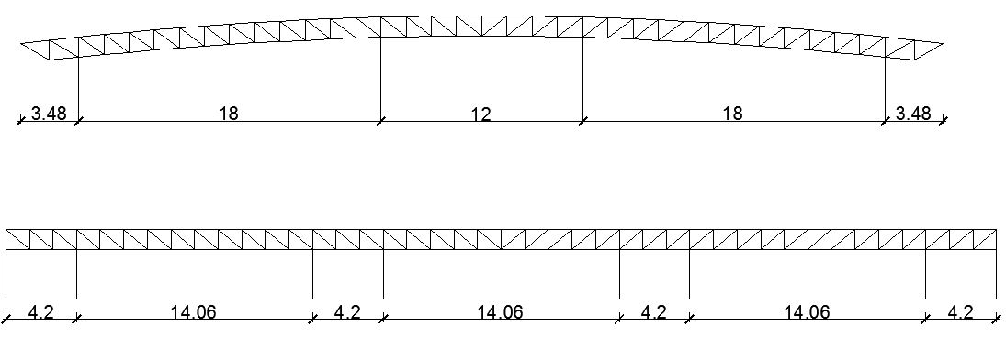

Figure 10: Section A-A (above) and Section D-D (below)

### Truss Design

Axial capacity of the sections under tension and compression are checked during the preliminary design stage and the sections shown in table are considered to be used as truss components.Tensile capacity of the members are found by using below equation

$P_{n}=F_{y}*A_{g}$

Compression capacity of the members are obtained by using below equation

$P_{n}=F_{cr}*A_{g}$

* When $\frac{KL}{r}≤4.71*\sqrt{\frac{E}{F_{y}}}$

$F_{cr}=\left[{0.658}^{\frac{F_{y}}{F_{e}}}\right]*F_{y}$

* When $\frac{KL}{r}>4.71*\sqrt{\frac{E}{F_{y}}}$

$F_{cr}=0.877F_{e}$ Fe=elastic buckling stress determined according to below equation

$F_{e}=\frac{π^{2}*E}{{\left(\frac{KL}{r}\right)}^{2}}$

Table 9: Selected components for the truss system

|  |  |
| --- | --- |
| **Function** | **Section** |
| Bottom Chord | 2UPN160 |
| Top Chord | 2UPN140 |
| Diagonals | 2L70x70x10 |
| Vertical Members | 2L70x70x10 |

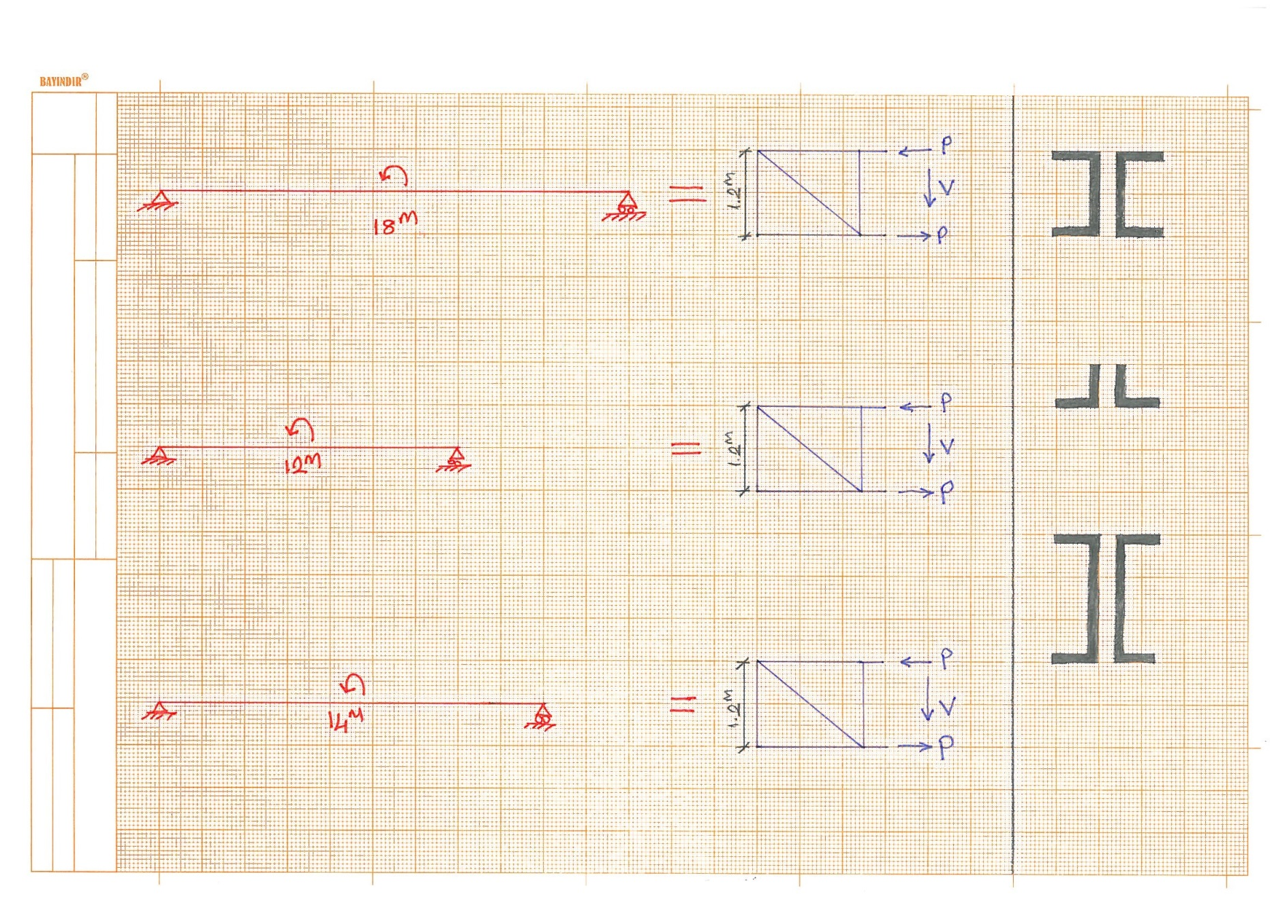

Figure 11: Truss and Purlin Analysis

Table 10: Calculated Critical Span Moments

|  |  |
| --- | --- |
| **Truss Span** | **Maximum Moments (kN*m)** |
| 18 meter Span | 513 |
| 14 meter Span | 245 |
| 12 meter Span | 228 |

### Purlin Design

In design of purlins, only flexural capacity of the sections is checked and after the calculations UPN200 is selected.

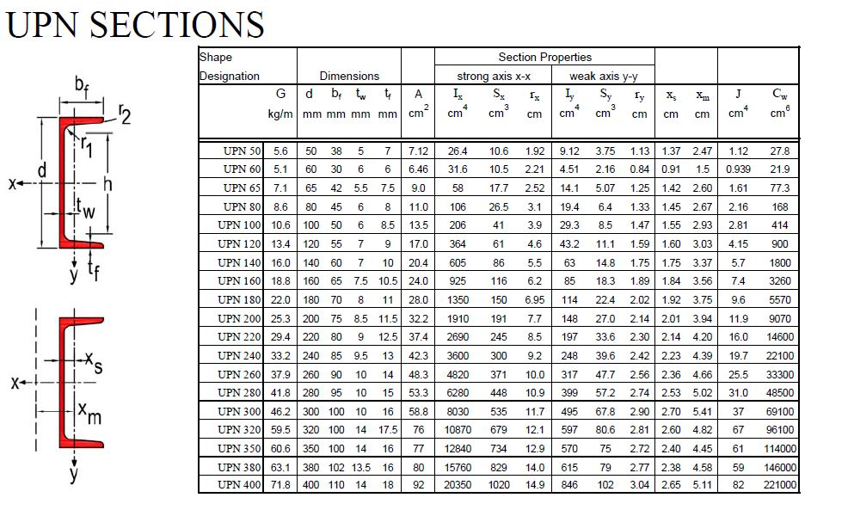

Figure 12: Section Properties of UPN200

Tributary area of a purlin is determined and the purlin located at the top of the roof is considered to be the most critical purlin. It is because this purlin does not make any angle with horizontal surface. Purlin midspan moment for the critical purlin is calculated as Md=20.9 kN*m

$M_{n}=M_{p}=F_{y}*Z_{x}$

Fy=Specified minimum yield stress of the type of steel being used (MPa)

Zx= Plastic section modulus about the x-axis (mm3)

## Slab Design and Alternatives

### Beam Slab System

Our concourse floor slab dimensions are 51.60 m length and 65.18 m width. Its area is approximately 3360 m2. First, we considered beam slab and divided as shown in the Figure 13. 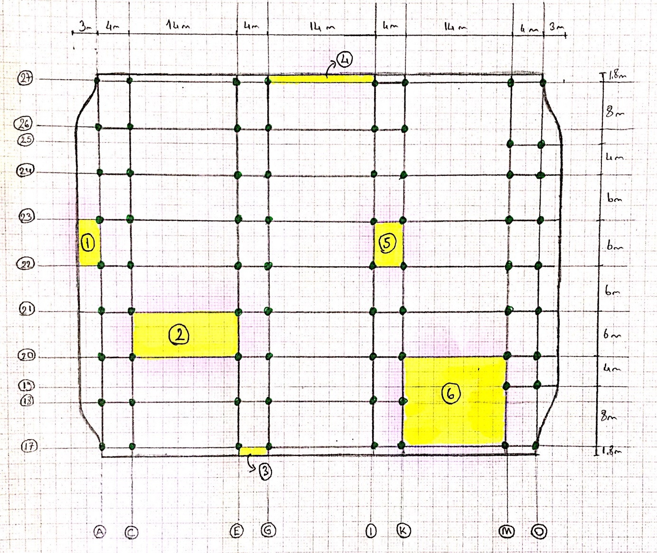

Figure 13: Beam Slab Plan

Slab-1, Slab-2, Slab-3, Slab-4, Slab-5 and Slab-6 are chosen to represent different types of slabs. Slab thickness is calculated for each slab according to TS500 requirements as follows:

**Slab-1:**

ll = 6 m, ls = 3 m ls: Short side of the slab, m=ll **/** ls **=** 2

Slab-1 is a cantilever slab. The thickness limitation for two-way slab is shown below. Minimum ratio of the thickness to the net distance in the short side cannot be smaller than 12.

3000/12 = 250 mm Minimum thickness requirement for Slab-1 is 25 cm.

**Slab-2:**

ll = 14 m, ls = 6 m m=ll **/** ls **=** 2.33

Since m is greater than 2, Slab-2 is one-way slab. The thickness limitation for one-way slab changes according to its types. Our slab is a continuous slab and minimum ratio of the thickness to the net distance in the short side cannot be smaller than 30.

6000/30 = 200 mm

Minimum thickness requirement for Slab-2 is 20 cm.

**Slab-3:**

ll = 4 m, ls = 1.8 m m=ll **/** ls **=** 2.22

Since m is greater than 2, Slab-3 is also one-way slab. Slab-3 is a cantilever slab and minimum ratio of the thickness to the net distance in the short side cannot be smaller than 12.

1800/12 = 150 mm

Minimum thickness requirement for Slab-3 is 15 cm.

**Slab-4:**

ll = 14 m, ls = 1.8 m m=ll **/** ls **=** 7.78

Since m is greater than 2, Slab-4 is also one-way slab. Slab-4 is a cantilever slab.

1800/12 = 150 mm

Minimum thickness requirement for Slab-4 is 15 cm.

**Slab-5:**

ll = 6 m, ls = 4 m m=ll **/** ls **=** 1.5

m is smaller than 2.

Hence, Slab-5 is two-way slab. The thickness limitation for two-way slab at TS500 is shown below formula. $$h≥\frac{l_{sn}}{15+\frac{20}{m}}*\left(1-\frac{α_{s}}{4}\right) and h≥80 mm$$

αs = 20/20 = 1

lsn = 4-0,6 = 3.4 m

m: aspect ratio = ll / ls = 6/4 = 1.5

$$h≥\frac{3400}{15+\frac{20}{1.5}}*\left(1-\frac{1}{4}\right)=90 mm$$

Minimum thickness for Slab-5 is 9 cm.

**Slab-6:**

ll = 14 m, ls = 12 m m=ll **/** ls **=** 1.17

m is smaller than 2.

Hence, Slab-6 is also two-way slab. The thickness limitation for two-way slab at TS500 is shown below formula. $$h≥\frac{l_{sn}}{15+\frac{20}{m}}*\left(1-\frac{α_{s}}{4}\right) and h≥80 mm$$

αs = 52/52 = 1

lsn = 12-0,6 = 11.4 m.

m: aspect ratio = 1.17

$$h≥\frac{11400}{15+\frac{20}{1.17}}*\left(1-\frac{1}{4}\right)=280 mm$$

Minimum thickness for Slab-5 is about 30 cm.

The load of slab and live load:

Weight of Slab = 0.3 * 25 kN/m2= 750 kg/m2 = 7.5 kN/m2

According to TS ISO 9194, specific weights of used materials are shown at Table 11.

Table 11: Specific Weights of Materials

|  |  |  |  |
| --- | --- | --- | --- |
|  | **Thickness(cm)** | **Unit Weight(kg/m3)** | **Weight (kPa)** |
| Slab | 30 | 2500 | 7.5 |
| Mortar | 2 | 1600 | 0.32 |
| Plaster | 2 | 1500 | 0.3 |
| Marble | 3 | 2700 | 0.81 |
| Floor Cover | 3 | 1800 | 0.54 |
|  |  | Total | 9.47 |

Also, we have partition walls on the Slab-6. Wall thickness is 20 cm and total length of the wall is about 85 m long and 3.5 m high. Unit weight of the hollow brick is 1350 kg/m3 according to TS ISO 9194.

Weight of the wall is = 0.2*1350 = 2.7 kN/m2

We have 85 m long and 3.5 m high wall, 2.7*85*3.5 = 803.25 kN

Our slab area for Slab-6 = 14*12 = 168 m2

Distributed load of the wall = 803.25/168 = 4.78 kN/m2

By using moment coefficients method for two way rectangular slabs with beams α can be found. From the TS-500 from the Table: 11.2 for all sides continuous slabs moment coefficients are found as follows:

In the short direction, positive moment at mid-span (+α): 0.033

In the short direction, negative moment at mid-span (-α): 0.044

In the long direction, negative moment at continuous support (-α): 0.033

In the long direction, positive moment at mid-span (+α): 0.025

Moment is calculated with the equation 11.3 TS-500

Md=α*Pd*lsn2 = 0.044*27.95*11.42=159.83 kN*m (Eqn 11.3) from TS-500 section 11.4.3)

Two-way slab is assumed as a beam with the width of 1 meter (bw=1 m) in order to calculate its thickness.

$K_{l}= \frac{b_{w}*d^{2}}{M_{d}}$

$K_{l}=247mm^{2}/kN$ For the C30 concrete

$247*159.83*1000=1000*d^{2}$

d=19.9 cm < 30 cm Selected thickness is sufficient for the applied load.

Table 12: Slab Properties

|  |  |  |  |  |  |
| --- | --- | --- | --- | --- | --- |
| **Slab** | **Longer Dimension (m)** | **Shorter Dimension (m)** | **m (aspect ratio)** | **Slab Type** | **Minimum Thickness Requirement (cm)** |
| Slab-1 | 6 | 3 | 2 | One-way | 25 |
| Slab-2 | 14 | 6 | 2.3 | One-way | 20 |
| Slab-3 | 4 | 1.8 | 2.2 | One-way | 15 |
| Slab-4 | 14 | 1.8 | 7.8 | One-way | 15 |
| Slab-5 | 6 | 4 | 1.5 | Two-way | 9 |
| Slab-6 | 14 | 12 | 1.2 | Two-way | 30 |

Our most critical slab is Slab-6 and it limits the thickness to minimum 30 cm.

### Beam Design for Beam Slab System

According to TS500 and TSC2007, a member can be called as beam if the following conditions are satisfied;

$N_{d}≤0.1*f_{ck}*A_{c}$

1. $h_{k}≥300 mm$ (hk is the depth of the beam)
2. $b_{w}≥250 mm$ (bw is the width of the beam )
3. $b_{w}≤b_{k}+h_{k}$ (bw is the width of the column)

$b_{w}≥200 mm$

Since there is no axial force in preliminary design stage, 1st equation shown above is not considered.

In two way slabs system, the loads are transferred to the beams in two different ways as the name implies. The loads are transferred as triangular distribution in the short direction whereas the loads are distributed in trapezoidal way in the long direction.

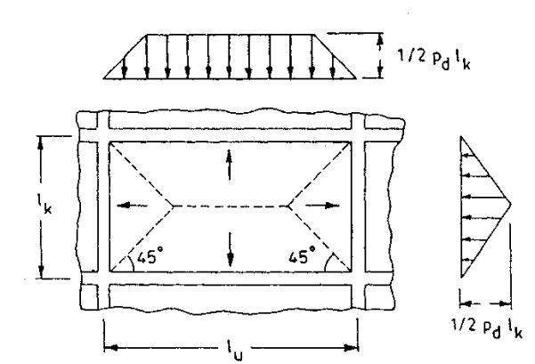

Figure 14: Load Transfer Mechanism in Two Way Slabs

The loads that are distributed as trapezoidal way can be converted uniform load distribution by using the equation-1 shown below and equation-2 can be utilized to convert triangular loading into uniform loading.

$\frac{P_{d}*l_{kn}}{3}*\left(1.5-\frac{0.5}{m^{2}}\right)$

$\frac{1}{3}*P_{d}*l_{sn}$

For Slab-6;

Pd=27.95 kN/m2

ll = 14 m, ls = 12 m m=ll **/** ls **=** 1.17

There is a distributed load of 126.86 kN/m on the beams having 14 meters of length and the moment is calculated as;

Md=2675.4 kN*m

$$K_{l}=\frac{b_{w}*d^{2}}{M_{d}}, K_{l}=247mm^{2}/kN$$**bw=60 cm and d=100 cm are selected as beam dimensions**

### Precast Slab System

Besides slab with beams, we also considered covering the long span slabs with precast slab panels. As shown Figure 15, we can place precast panels for our biggest slab.

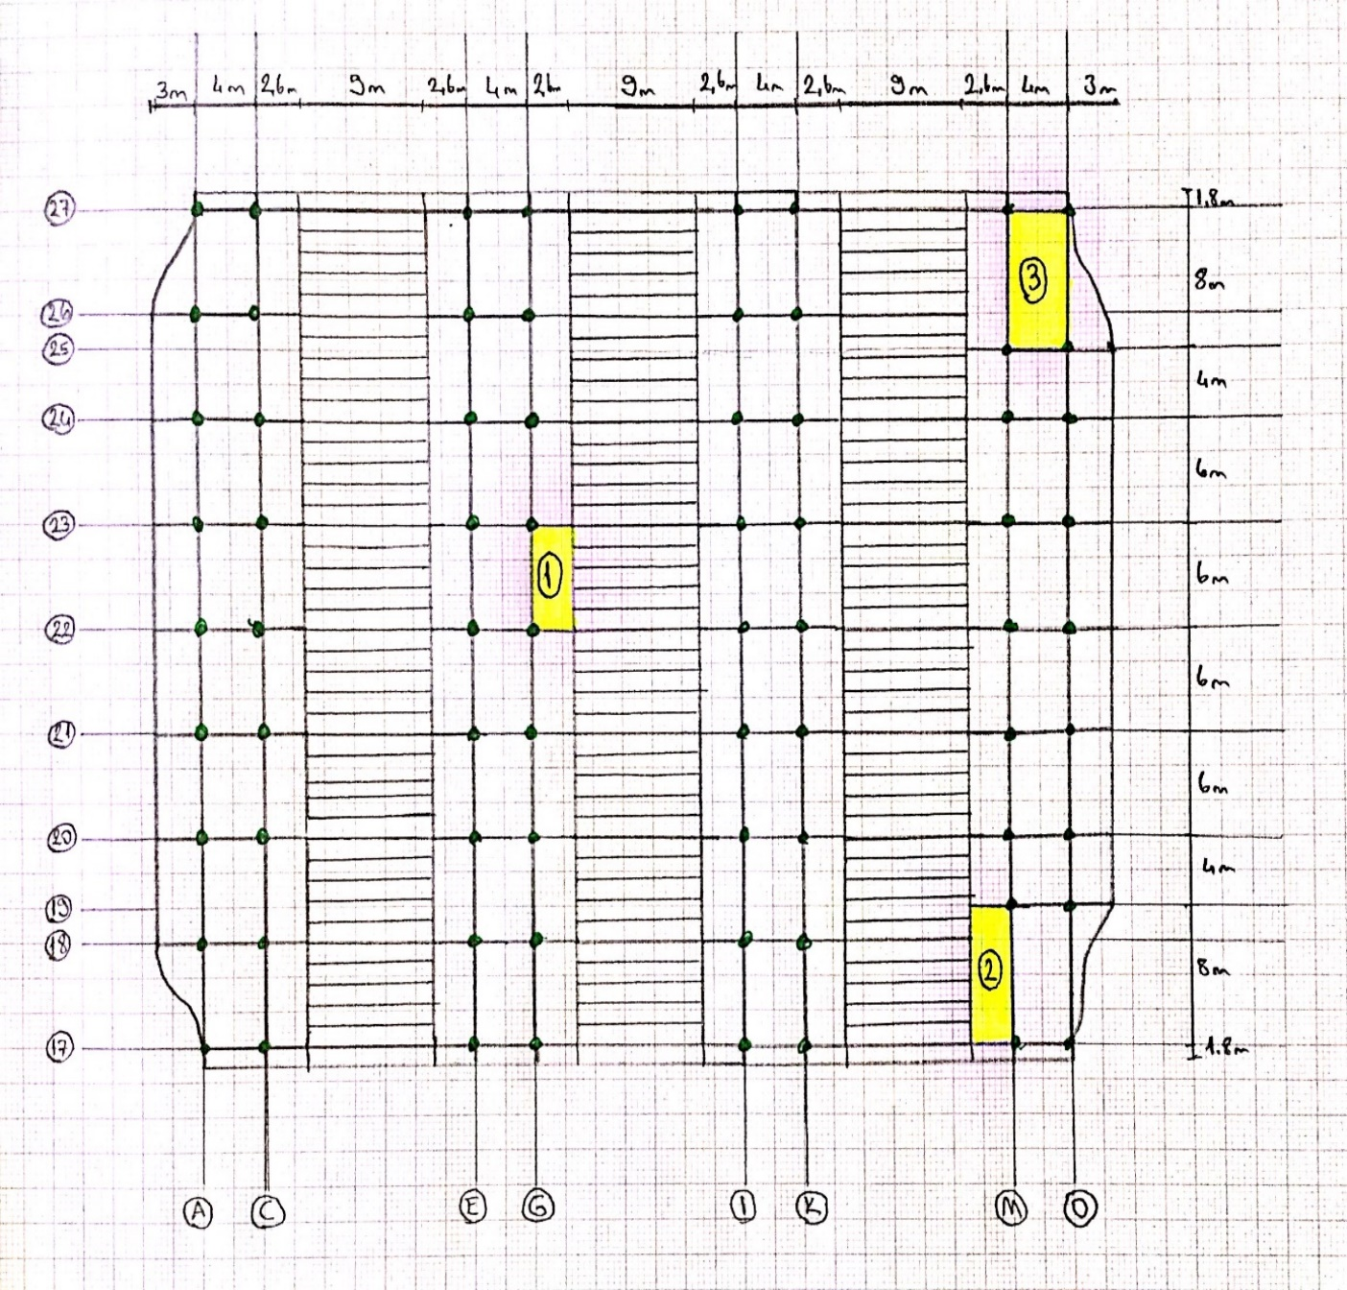

Figure 15: Slab Plan with Precast Panels

We have chosen Slab-1, Slab-2 and Slab-3 to determine slab limitations.

**Slab-1:**

ll = 6 m, ls = 2.6 m ls: Short side of the slab, m=ll **/** ls **=** 2.31

Since m is greater than 2, Slab-1 is one-way slab. The thickness limitation for one-way slab changes according to its types. Our slab is a continuous slab and minimum ratio of the thickness to the net distance in the short side cannot be smaller than 30.

2600/30 = 86.7 mm

Minimum thickness requirement for Slab-1 is 9 cm.

**Slab-2:**

ll = 8 m, ls = 2.6 m ls: Short side of the slab, m=ll **/** ls **=** 3.08

Since m is greater than 2, Slab-1 is one-way slab. The thickness limitation for one-way slab changes according to its types. Our slab is a continuous slab and minimum ratio of the thickness to the net distance in the short side cannot be smaller than 30.

2600/30 = 86.7 mm

Minimum thickness requirement for Slab-2 is 9 cm.

**Slab-3:**

ll = 8 m, ls = 4 m ls: Short side of the slab, m=ll **/** ls **=** 2

m is equal to 2.

Hence, Slab-3 is two-way slab. The thickness limitation for two-way slab at TS500 is shown below formula. $$h≥\frac{l_{sn}}{15+\frac{20}{m}}*\left(1-\frac{α_{s}}{4}\right) and h≥80 mm$$

αs = 24/24 = 1

lsn = 4-0,6 = 3.4 m

m: aspect ratio = 2

$$h≥\frac{3400}{15+\frac{20}{2}}*\left(1-\frac{1}{4}\right)=102 mm$$

Minimum thickness for Slab-3 is 11 cm.

Table 13: Slab Properties

|  |  |  |  |  |  |
| --- | --- | --- | --- | --- | --- |
| **Slab** | **Longer Dimension (m)** | **Shorter Dimension (m)** | **m (aspect ratio)** | **Slab Type** | **Minimum Thickness Requirement (cm)** |
| Slab-1 | 6 | 2.6 | 2.3 | One-way | 9 |
| Slab-2 | 8 | 2.6 | 3.1 | One-way | 9 |
| Slab-3 | 8 | 4 | 2.0 | Two-way | 11 |

Let’s choose slab thickness as 20 cm.

Table 14: Specific Weight of the Materials

|  |  |  |  |
| --- | --- | --- | --- |
|  | **Thickness(cm)** | **Unit Weight/m^2** | **Weight (kPa)** |
| Slab | 20 | 2500 | 5 |
| Mortar | 2 | 1600 | 0.32 |
| Plaster | 2 | 1500 | 0.3 |
| Marble | 3 | 2700 | 0.81 |
| Floor Cover | 3 | 1800 | 0.54 |
|  |  | Total | 6.97 |

$$P_{d}=1,4G+1,6Q=1,4*\left(6.97+4.78\right)+1,6*5=24.45 kN/m^{2}$$

By using moment coefficients method for two way rectangular slabs with beams we can find α for Slab-3. From the TS-500 from the Table: 11.2 for all sides continuous slabs moment coefficients are found as follows:

In the short direction, positive moment at mid-span (+α): 0.062

In the short direction, negative moment at continuous support (-α): 0.083

In the long direction, negative moment at continuous support (-α): 0.033

In the long direction, positive moment at mid-span (+α): 0.025

Moment is calculated with the equation 11.3 TS-500

Md=α*Pd*lsn2 = 0.083*24.45*3.42=23.46 kN*m (Eqn 11.3) from TS-500 section 11.4.3)

Two-way slab is assumed as a beam with the width of 1 meter (bw=1 m) in order to calculate its thickness.

$K_{l}= \frac{b_{w}*d^{2}}{M_{d}}$

$K_{l}=247mm^{2}/kN$ For the C30 concrete

$247*23.46*1000=1000*d^{2}$

d=7.1 cm < 20 cm Selected thickness is sufficient for the applied load.

According to recent precast producers’ products, we can choose panels related with the applied loads. Figure 16 shows one of the produces product catalog.

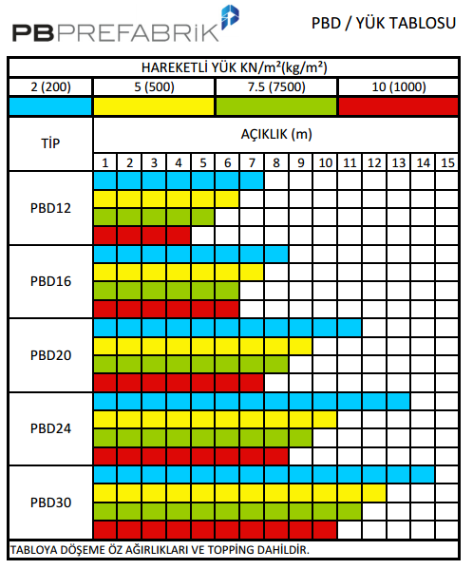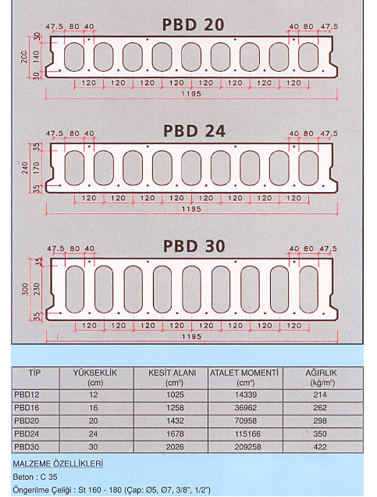

Figure 16: Precast Slab Options

In the first case, we considered continuous beams in each direction and found out that slab thickness cannot be smaller than 30 cm. On the other hand, if we consider precast slabs, we can choose PBD24 from specified catalog. By choosing this type of panel, we can pass 9 m span with a live load of 7.5 kN/m2. Moreover, slab thickness will be 24 cm. If we choose to use precast slab, we will use less material and total weight of the structure will decrease.

### Beam Design for Precast Slab System

There is a distributed load of 41 kN/m on the beams having 8 meters of length and the moment is calculated as;

Md= kN*m

$$K_{l}=\frac{b_{w}*d^{2}}{M_{d}}, K_{l}=247mm^{2}/kN$$**bw=60 cm and d=60 cm are selected as beam dimensions**

* It is important to note that this beam carries the precast slabs.

## Column Design and Locations

At the preliminary design stage, the aim is to locate the columns on plan, to estimate axial load on the columns by considering gravity loads that are members weight, roof cover weight and live loads like snow load, and to determine the cross sectional dimensions of the columns.Lateral loads like earthquake and wind loads are not considered in the preliminary design stage of the columns.

### Design of columns on the ground floor

There are 72 circular reinforced concrete columns on the ground floor. The location of the columns can be seen in **figure 17** . Height of the all columns is 6 meter.

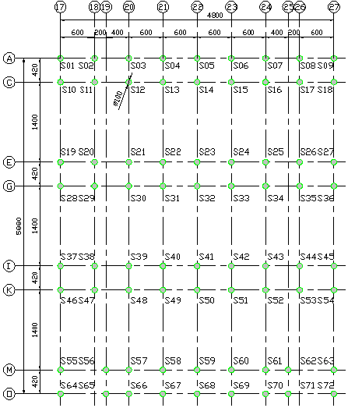

**Figure 17: Location of the ground floor columns**

According to TS 500, cross section of the columns can be found by following formula and code says that axial loads are considered as only gravity loads that are dead load and live load. Also, code says that circular reinforced concrete columns have to be minimum 300 millimeter.

Nd ≤ 0,9 * fcd * Ac

According to Turkish Seismic Code, minimum cross section area of the columns is found by using following formula but design axial load includes earthquake load. At this stage, earthquake loads are not considered but in order to be in safe side, this formula is used in calculations.

Nd ≤ 0,75 * fcd * Ac

All gravity loads are listed as follows:

Weight of slab: 7,5 kN/m2

Weight of beams: 4,5 kN/m2

Weight of roof: 0,35 kN/m2

Weight of snow: 0,75 kN/m2

Weight of roof floor cover: 0,15 kN/m2

Weight of first floor column: 0,32 kN/m2

Weight of walls: 1,7 kN/m2

Therefore, total dead load can be taken as sum of weight of slab, beams, roof, floor cover, first floor cover and walls. It is 14,5 kN/m2. Live load is snow load and it is 0,75 kN/m2.

Pd = 1.4G + 1.6Q

Therefore, axial load is Pd = 1.4 x 14,5 + 1.6 x 0,75 = 21,5 kN/m2

In order to find most critical column, tributary area of the each column is determined and most critical columns are found. Except edge columns, all columns are critical. All these columns’ tributary area is 54,6 m2 so axial load acting on the critical columns Nd can be taken as 1174 kN by multiplying 21,5 kN/m2 and 54,6 m2.

Minimum Ac is found as 78267 mm2 for axial loading. Columns diameter is 1 meter in architectural plan. The cross section area of 1 meter diameter circular columns is 785400 mm2 that is much more than minimum Ac. It means that 1 meter diameter circular columns are enough for axial load acting on them. Also, it seems to be huge difference between 1 meter circular column cross section area and minimum Ac but it is just for axial loads. In other words, earthquake load, wind load or temperature load are not considered. Therefore, diameter of the circular reinforced concrete columns are chosen 1 meter.

### Design of first floor columns

There are 32 columns on the first floor of Feneryolu Metro Station. It is possible to say that all 32 columns can be circular reinforced concrete or steel. Both of them have their advantages and disadvantages so these two options are studied separately.

#### Steel column case

All steel columns’ location can be seen in **Figure …** Height of the columns is not same due to existing of the curve roof. Middle of the 16 columns’ height is 4,45 meter and outside of the 16 columns height are 3,30 meter.

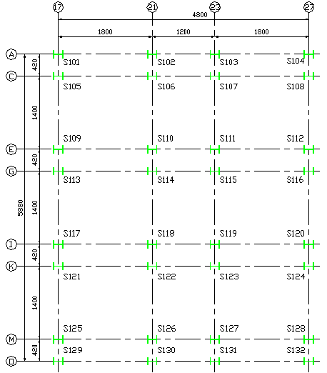

**Figure 18: Steel columns location of the first floor**

First floor columns carry weight of roof members, roof cover load and snow load. Dead load carrying by steel columns is 0,35 kN/m2 for member weight and 0,15 kN/m2 for roof cover load. Live load is 0,75 kN/m2 for snow load.

Pd = 1,2G + 1,6Q

Pd  = 1,2*0,50 + 1,6*0,75 =1,8 kN/m2

By calculating tributary area of the each column, the most critical columns are found. Those are S106, S107, S110, S111, S114, S115, S118, S119, S122, S123, S126 and S127. All columns tributary area is 136,5 m2. Therefore, the each critical column carries 244,8 kN

All columns section is chosen HEA400. Then slenderness of the section is checked.

According to AISC, for local buckling the width (b) to thickness (t) ratios of the compression elements shall not exceed $0,56\sqrt{\frac{E}{Fy}}$. In order to be nonslender element section.(B4-1 in AISC) For HEA400:

b/t = 150/14 = 10,7

$0,56\sqrt{\frac{E}{Fy}}$. = $0,56\sqrt{\frac{200000}{275}}$. = 15

b/t < $0,56\sqrt{\frac{E}{Fy}}$. Therefore, section is nonslender.

After that, these sections’ capacities are calculated by considering flexural buckling of members with nonslender elements.

For HEA 400:

$4.71\sqrt{\frac{E}{Fy}}$ = $4.71\sqrt{\frac{200000}{275}}$ =127

)strong = = 118,9 where K value in strong axis is 4.5 from the alignment chart (Figure C-A-7.2. in AISC)

)weak = = 121,3 where K value in weak axis is 2 from effective length factor table (Table C-A-7.1 in AISC)

Therefore, )weak governs due to more critical than in strong axis.

Therefore,)weak <  condition occurs: (121,3 < 127 )

Fcr = (0,658Fy/Fe ) x Fy where Fe = $\frac{П2E}{(\frac{KL}{r})2}$ = 134,2 MPa

Fcr = (0,658275/134,2 ) x 275= 116,6 MPa

Area of HEA400 is 15900 mm2 so capacity of the section (ФPn ) can be found as Fcr x Ag

ФPn = 0,9 x 116,6 x 15900 x 10-3 = 1669 kN which is bigger than applied load 244,8 kN. Section is safe under this condition.

To sum up, HEA400 is okay when axial load that consists of dead load of the roof, snow load and roof cover load is considered.

#### Circular reinforced column case

By using minimum cross section area formula in Turkish Seismic Code, diameter of the circular reinforced columns can be found.

mm2 where Nd = 244,8 kN

min. Ac = = 16320 mm2  < 75000.

Therefore, load acting on the columns is considerably small. When 60 cm diameter is chosen for circular section, columns can carry Nd = x 3002 x 0.75 x 30/1,5 x 10-3 = 4241 kN which is much more than acting load on the all columns. Therefore, first floor column diameter of the station can be chosen as 0.6 meter.

In preliminary design stage of the first floor columns, there are two options that are already mentioned as circular reinforced concrete and steel. Ground floor columns are circular reinforced concrete with 1 meter dimeter. If first floor columns are chosen steel, there is need to anchorage in connection between ground floor circular reinforced concrete column and steel column. Connection between roof and steel columns can be supplied with bolts. Similarly, if first floor columns are chosen as circular reinforced concrete column, there is need to anchorage in connection between roof and circular reinforced concrete column. An advantage of using steel columns is that construction of it is faster than construction of circular reinforced concrete column. Also, circular formwork for reinforced concrete columns is a challenge in construction market but there is no necessity for steel. It is possible that steel columns can be covered with circular membrane but it is not much unattainable. A disadvantage of using circular reinforced concrete is that extension of longitudinal reinforcements of the ground floor columns has to be bent 20 cm to center of the column due to difference of the diameters. It is possible to say that using of circular reinforced concrete column may be more economical than using of steel. To sum up, using steel column and circular reinforced concrete column have their advantages and disadvantages. It is considered that both of them will be designed and the decision of which one is used in Feneryolu Metro Station will be clear when cost estimation is performed.

## Geotechnical Design

In this part of report, there are information about geotechnical properties and preliminary design of foundation. For our Marmaray Station Project, a soil investigation report of a dwelling house project in Ankara is given us. According to investigation of borehole logs, field and laboratory tests, an idealized soil profile with estimated and correlated soil parameters is determined. Moreover, the dimensions and type of foundation is estimated based on estimated settlement and structure loads.

## Site Investigation and Idealized Soil Profile

There are 9 different boreholes with the total depth of 235.00 m in field work. The depth and location of each borehole log is given below.

Table 15: Depth of Borehole Logs

|  |  |
| --- | --- |
| **No. Of Borehole (BH)** | **Depth (m)** |
| BH-1 | 30.00 |
| BH-2 | 25.00 |
| BH-3 | 30.00 |
| BH-4 | 25.00 |
| BH-5 | 30.00 |
| BH-6 | 25.00 |
| BH-7 | 25.00 |
| BH-8 | 30.00 |
| BH-9 | 15.00 |

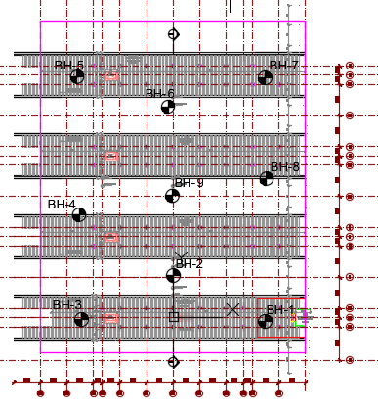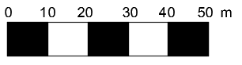

Figure 19: Location of Boreholes

In accordance with land survey, the most dominant soil type is silty clay for soil under our project. In order to estimate the soil parameters, all laboratory test results and borehole data are used. One thing to note is that, as a common geotechnical engineering practice, depth of a borehole should be taken as 3*B for strip foundation. We have 4 platform foundations and their width is 10.0 m So, our borehole depth is computed as 30 m. Maximum borehole depth is given as 25 m in the corresponding geotechnical site report for the station. Since given borehole depth is not enough, calculations are done accordingly, if it is necessary to examine greater depths, it is convenient to make assumptions by stating them in the report as well.

Obtained soil parameters are explained in the following:

Fine and coarse content are determined from sieve analysis test results.

Liquid Limit, Plastic Limit, and Plasticity index values are taken from Atterberg Test Results.

Water content and unit weight of soil are taken from laboratory test results.

The obtained results of above information are tabulated in Table 16.

Table 16: Some soil parameters obtained laboratory test results

|  |  |
| --- | --- |
| **Group Symbol** | Clay (CH, CL) & Silt (MH, ML) |
| **Fine Material Ratio** | F(%) = 50.8 – 96.3 => Estimated Value of F(%) = 80.0 |
| **Coarse Material Ratio** | C(%) = 0.0 – 12.6 => Estimated Value of C(%) = 1.0 |
| **Water Content** | w(%) = 15.2 – 40.9 => Estimated Value of w(%) = 26.0 |
| **Liquid Limit** | LL(%) = 50.8 – 96.3 => Estimated Value of F(%) = 50.0 |
| **Plastic Limit** | PL(%) = 50.8 – 96.3 => Estimated Value of F(%) = 27.0 |
| **Plasticity Index** | PI(%) = 50.8 – 96.3 => Estimated Value of F(%) = 23.0 |
| **Unit Weight (kN/m3)** | ɣ(%) = 16.07–20.30 => Estimated Value of ɣ(%) = 18.5 kN/m3 |

After determining some soil parameter from laboratory test results, the other needed soil parameter are computed and correlated based on geotechnical design criteria.

Firstly, since the given SPT N values are N45, they are corrected based on the Energy Ratio to find N60. In other words, given SPT-N values are multiplied with 0,45/0,6= 0,75 (N60 = 0.75*N) and SPT N60 numbers are obtained accordingly.

According to laboratory test results (Unconfined undrained triaxial test & unconfined compression test), undrained shear strength (cu) of soil is calculated in the following Table 17:

Table 17: Undrained Shear Strength based on Laboratory Tests

|  |  |  |  |
| --- | --- | --- | --- |
| **Description** | **cu (kPa)**  **(Lab)** | **qu (kPa)**  **(Lab)** | **cu (kPa)**  **(qu/2)** |
| Silty Clay | 85.0- 350.0  (ave. 185) | 158.7 – 375.4  (ave. 235) | 120 |

Then, undrained shear strength (cu) of soil is calculated in according to recommendations of Kulhawy and Mayne (1990) and Stroud (1974). Kulhawy and Mayne (1990) stated that relation between (cu/pa) and SPT-N given in Table 18 can approximately be represented by (cu/pa) = 0.06*N.

Table 18: Relation between SPT N – cu (Terzaghi and Peck, 1967)

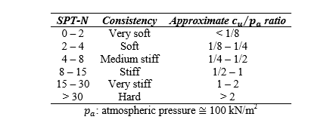

(cu/pa) = 0.06*N

Table 19 : Undrained Shear Strength according to Kulhawy and Mayne (1990)

|  |  |  |  |  |
| --- | --- | --- | --- | --- |
| **Description** | **Nave** | **(cu/pa) ratio** | **pa (kN/m2)** | **cu (kPa)** |
| Silty Clay | 50 | > 2 | 100 | 300 |

Also, Stroud (1974) proposed a correlation between f1 (is a factor depending on plasticity index) and PI as shown in Figure 20 and cu (kN/m2) = f1*N60 .

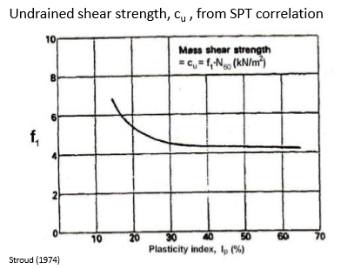

Figure 20 : Relation between SPT- N60 – cu – PI (Stroud, 1974)

Table 20 : Undrained Shear Strength according to Stroud (1974)

|  |  |  |  |  |
| --- | --- | --- | --- | --- |
| **Description** | **Nave** | **PI (%)** | **f1** | **cu (kPa)**  **(Stroud)** |
| Silty Clay | 50 | 23 | 5 | 250 |

For long term parameters of silty clay soil, effective angle of shearing resistance can be estimated from Figure 20 or Figure 21. These figures include some correlations between plasticity index and effective friction angle which are recommended by Terzaghi, Peck, & Mesri (1996) and Gibson (1953).

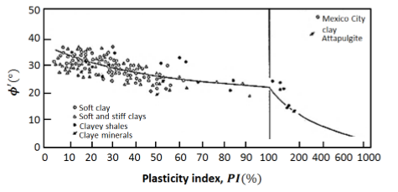

Figure 21: Relation between plasticity index – Ф’ (Terzaghi, Peck and Mesri, 1996)

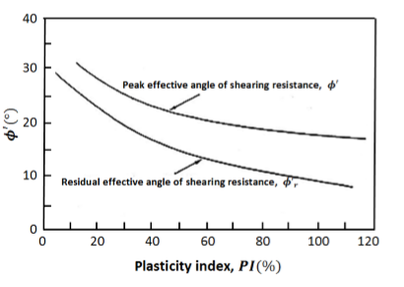

Figure 22: Relation between plasticity index – Ф’ (Gibson, 1953)

Table 21: Effective friction angle of shearing resistance

|  |  |  |  |
| --- | --- | --- | --- |
| **Description** | **PI (%)** | **Ф’ (o)** | |
| **Terzaghi, Peck, Mesri (1996)** | **Gibson (1953)** |
| Silty Clay | 23 | 30 | 28 |

In according to above calculation, for long and short term shear strength parameters of silty clay soil can be taken as the following:

Table 22: Shear strength Parameter for drained and undrained conditions

|  |  |  |  |  |  |
| --- | --- | --- | --- | --- | --- |
| **Description** | **cu**  **(kPa)** | **Фu** | **c’**  **(kPa)** | **Ф’** | **ɣ**  **(kN/m3)** |
| Silty Clay | 200 | 0 | 15 | 29 | 18.5 |

The coefficient of compressibility (mv) can be obtained from Stroud (1974) chart:

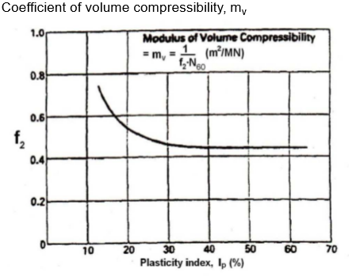

Figure 23: Estimation of mv based on relation between f2 – PI - SPT N

Table 23: Obtained coefficient of compressibility based on Stroud (1974) recommendation

|  |  |  |  |  |
| --- | --- | --- | --- | --- |
| **Description** | **Nave** | **PI (%)** | **f2** | **mv (m2/MN)**  **(Stroud)** |
| Silty Clay | 50 | 23 | 0.5 | 0.04 |

Undrained deformation modulus (Eu) can be estimated based on undrained shear strength or average SPT N value;

* Duncan&Buchignani (1976) suggested that Eu = 100 – 300cu and,
* Butler (1975) proposed that Eu/N60 = (1 – 1.2) (MN/ m2)

Table 24: Obtained Eu based on undrained shear strength or average SPT N value

|  |  |  |  |  |
| --- | --- | --- | --- | --- |
| Description | cu (kPa) | Nave | Eu (kPa) | |
| Duncan& Buchignani (1976) | Butler (1975) |
| Silty Clay | 200 | 50 | 20000 - 60000 | 50000 - 60000 |

All estimated soil parameters for all layers for long and short term conditions are shown below:

Table 25: Soil Parameters of Silty Clay Soil

|  |  |  |  |  |  |  |  |
| --- | --- | --- | --- | --- | --- | --- | --- |
| Description | cu  (kPa) | Фu | c’  (kPa) | Ф’ | ɣ  (kN/m3) | mv (m2/kN) | Eu  (kPa) |
| Silty Clay | 200 | 0 | 15 | 28 | 18.5 | 0.40*10-4 | 45000 |

In the light of test results which are taken from boring holes, idealized soil profile is drawn below Figures 24.

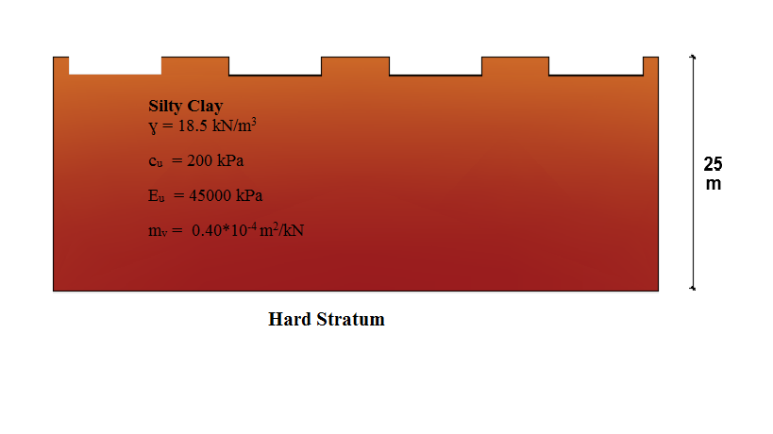

Figure 24: Idealized Soil Profile

## Foundation Type and Characteristics

There are 4 platforms in this project and the dimensions of each platform are 10.00 m*59.80 m. Depth of foundation is considered as 2 m since the depth of frost zone is 1.5 m. A continuous foundation will be design for each platform and the thickness of foundation is assumed as 50 cm.

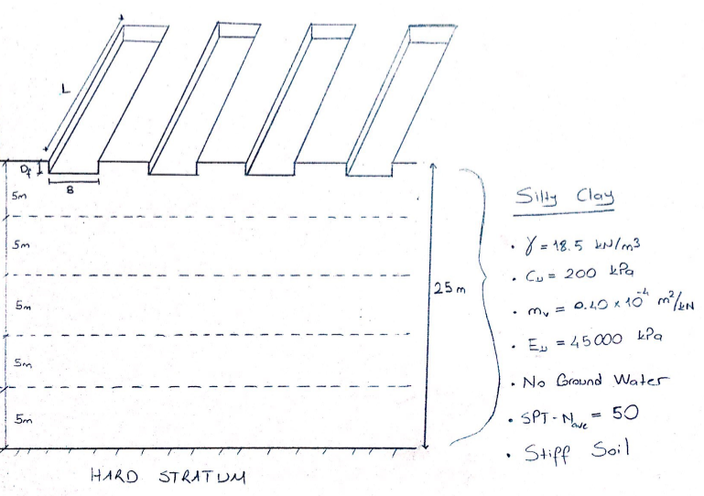

Figure 25: Representation of Foundation Dimensions and Soil Profile

In our foundation, there is swelling case and its pressure is 17.5 kPa. To prevent the uplift of the structure, the thickness of foundation is chosen as 50 cm. We also need to check punching effect on foundation.

Punching check for continuous foundation;

In order to check punching, the following formulas are used;

* Vpc = ɣ*fctd*Up* d
* Vpd = Nd - Fa
* Fa = q*A

Where, Vpc: Punching shear capacity

ɣ : load factor ( take as 1.0)

fctd: tension capacity of concrete (for C30, fctd = 2.56 MPa)

Up: Critical path perimeter

d: effective depth

Vpd : required design shear strength capacity

Nd: Axial load on the columns

Fa : Force due to soil reaction

q: soil pressure due to column load

A: critical area (A= п*(r + d)2)

The middle two platforms are critical for punching. You can see the representation of these platforms and column location in Figure 8. In one platform, there are 18 circular columns and their diameter is 100 cm. 26666.7 kN force is applied to middle one platform. Assume each column takes same force, so force on column is calculated as 1481.5 kN.

And the clear cover length of foundation is 2 cm. Hence the effective depth (d) = 48 cm.

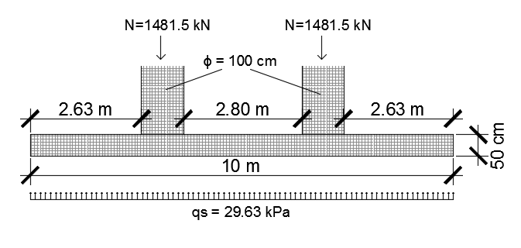

Figure 26: Representation of foundation and column in case of punching

In punching calculation the critical path perimeter (Up) is important. In figure 9, there are 3 different critical paths. The smaller critical path perimeter should be taken into consideration such as Up1 = 6.16 m.

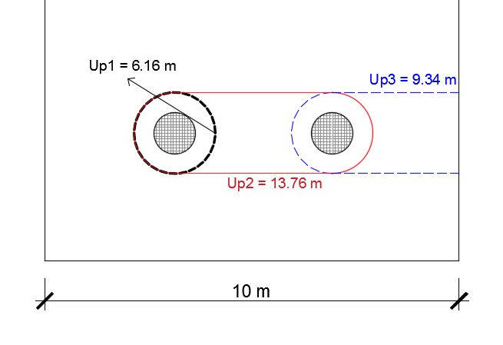

Figure 27: Representation of All Critical Paths

Vpc = 1*2.56*6160*480*10-3 = 7569.4 kN

q =

Fa = 44.6*(п*(0.5+0.48)2) = 134.6 kN

Vpd = 2*1481.5 – 134.6 = 2828.4 kN

Vpc > Vpd

Hence, this foundation is safe for the punching effect.

## Bearing Capacity

The bearing capacity formula of foundation on clays is written as;

qf = Cu*Nc + ɣ*D

Where, for Nc value Skempton (1951) proposed a chart for design of foundations on clay (see Figure 28).

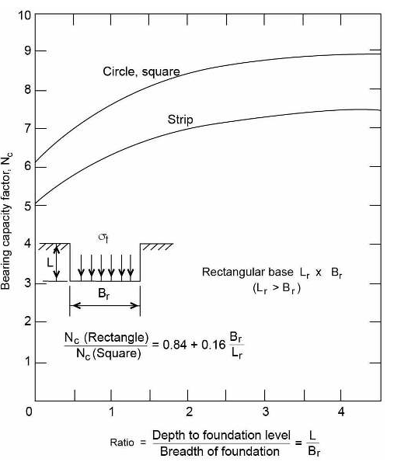

Figure 28: Bearing capacity factors for foundations in clay (F=0) after Skempton 1951.

* Df = 2 m (Depth of Foundation)
* Factor of Safety = 3.0
* Total Ultimate Bearing Capacity : qf = Cu*Nc + ɣ*D = 200*5.2 +18.5*2 = 1077 kPa
* Net bearing Capacity : (qnet)ultimate = qf - ɣ *D = Cu*Nc =1040 kPa
* Net safe Bearing Capacity : (qnet)safe = qnet / F.S. =(1040/3)=347 kPa
* Total Safe Bearing Capacity : (qtotal)safe = (qnet)safe + ɣ *Df = 347 +18.5*2 = 384 kPa

Table 26 : Bearing Capacity for Foundation of One Platform

|  |  |  |  |  |  |  |  |
| --- | --- | --- | --- | --- | --- | --- | --- |
| Structure | Type of Foundation | B*L (m) | Nc | cu(kPa) | (qnet)safe (kPa) | ɣ*Df | (qtotal)safe  (kPa) |
| Marmaray  Station (on 4 platforms) | Continuous Foundation | 10.0* 59.80 | 5.2 | 200 | 347 | 37 | 384 |

### Calculation of Net Foundation Pressure

The loads of the building were determined based on dead and live load calculations of the structural system. In addition to loads of the building, foundation characteristics and load can also be seen in Table 12.

Building Load = 8000 tons, Q = 8000*10 = 80000 kN

There are 4 platforms. The middle two platforms take 2Q load and the out two platforms take Q load.

6Q = 80000 kN => Q= 13333.3 kN and 2Q = 26666.7 kN

Area of one platform, A = 10*59.80 = 598 m2

Pressure on the foundation of middle platform, q = (26666.67)/(598) = 44.6 kPa

**Table 27: Foundation Characteristics of One Platform**

|  |  |
| --- | --- |
| Type | Continuous Foundation |
| Width | 10.0 m |
| Thickness | 0.50 m |
| Length | 59.80 m |
| Area | 10*59.80 = 598 m2 |
| Volume | 598*0.5 = 299 m3 |
| Concrete Unit Weight | 25 kN/m3 |
| Weight | 299*25 = 7475 kN |
| Pressure | 7475/ 598 = 12.5 kPa |

qgross = 44.6 + 12.5 = 57.1 kPa

qnet = 57.1 - 2*18.5 = 20.1 kPa

F.S. = (qult)net / qnet = (1040/22) = 46.02 > 3.0 so it is safe

(qtotal)safe = 384 kPa > qgross =57.1 kPa

When considering the swelling pressure (qswelling = 17.5 kPa) ;

qnet = 57.1 – (2*18.5 + 17.5 ) = 2.6 kPa

F.S = (qult)net / qnet = 1040/ 2.6 > 3.0 SAFE.

## Settlement of Continuous Foundation

### Immediate Settlement

A procedure that gives average vertical settlement under a flexible area carrying a uniform pressure q is followed for immediate settlement of foundations on clay layer. $$Si=µ0*µ1*\frac{q*B}{E}$$

Where, µ0, µ1= empirical factors dependent on the foundation geometry  
 B=Width of the foundation   
 E=Deformation Modulus  
the empirical factors can be estimated using the charts given in Figure 29 below.

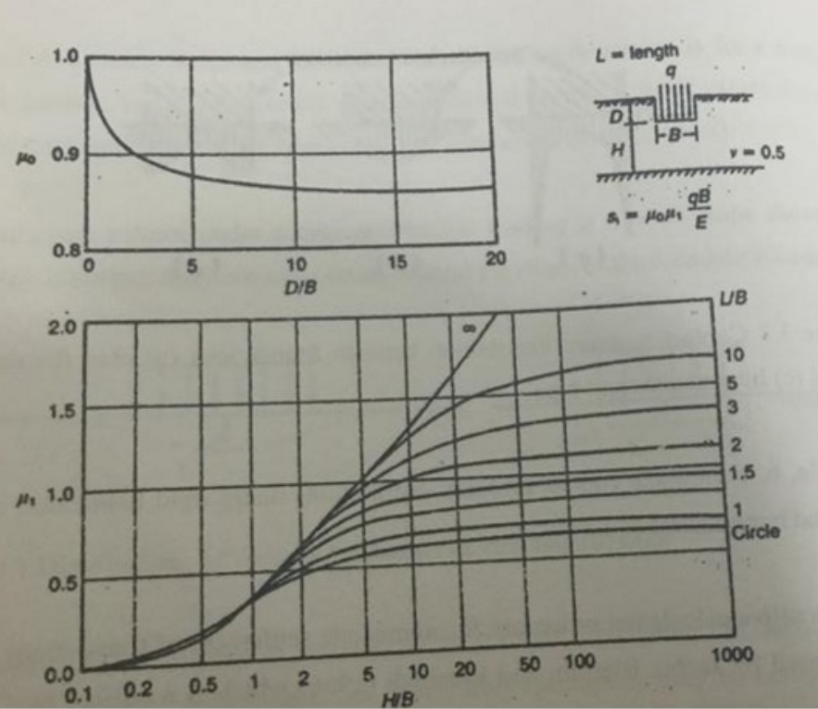

Figure 29: Empirical correlation factors for immediate settlement calculation

In our case D/B=2/10 = 0.5, so from chart µ0 can be taken as 1.0

In the case of swelling pressure, the thickness of compressible layer, H can be taken as the length of width, B= 10.0 m.

Hence, L/B = 59.80/10.0 = 5.98 and H/B = 1. Then, from chart µ1=0.4

Undrained deformation modulus had been calculated as 45000 kPa before.

And the net pressure on the foundation was calculated as 2.6 kPa. Assuming single soil layer under the foundation, the problem can be simplified into the following Figure 30.

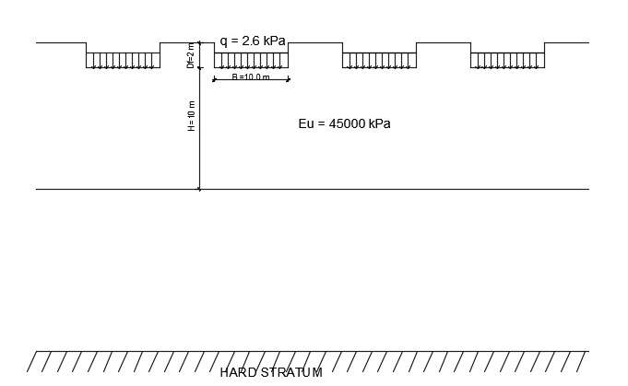

Figure 30: Representation of the Immediate Settlement Case

Then,

$$Si=1. 0*0.4*\frac{2.6*10}{45000}=0.00023 m$$

### Consolidation Settlement

There swelling pressure in foundation, since the distance between two platforms is great enough (8.20 m), there is no need to calculate the stress increasing due to overlapping. Only the settlement calculation due to net foundation pressure will be enough. Because the net foundation pressure is small, the thickness of settlement layer can be taken as width of the foundation such as; H = B = 10.0 m. And to calculate the settlement properly, layer should be divided to two layers. (see Figure 31)

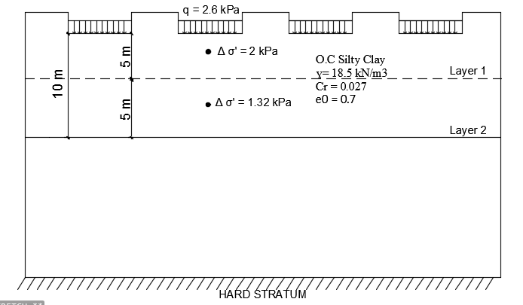

Figure 31: Representation of the Consolidation Settlement Case

In order to calculate the consolidation settlement, the following formula can be used;

$$Soed= \sum{[H*\frac{Cr}{1+e0}*log⁡(\frac{{σ0}^{'}+ ∆σ'}{σ0'}})$$

Where,

* Initial void ratio, e0= 0.7 which obtained from laboratory test results.
* Recompression index, Cr is obtained based on some correlations. According to recommendation of Terzahgi and Peck (1967), there is a relationship between compression index and liquid limit (LL) for clays of low and medium sensitivity;

LL = 50 % which is calculated before.

Cc = 0.009*(LL – 10 ) = 0.009*(50-10) = 0.36

And based on some correlations (Carter& Bentley, 1991), Cr is defined as

Cr = 5-10%* Cc  = > Cr = (7.5%)* 0.36 = 0.027

* For layer 1;

Initial effective overburden stress, σ’v,0 = (18.5*4.5) = 83.25 kPa

Stress increment due to foundation loading is calculated from1 Horizontal 2 Vertical rule. Δσ’ = 2 kPa

Final stress σ’v,f = 83.25 + 2 = 85.25 kPa

* For layer 2;

Initial effective overburden stress, σ’v,0 = (18.5*9.5) = 175.75 kPa

Stress increment due to foundation loading is calculated from1 Horizontal 2 Vertical rule. Δσ’ = 1.32 kPa

Final stress σ’v,f = 83.25 + 2 = 177.07 kPa

$$Soed=\left[ 5*\frac{0.027}{1+0.7}*\log\left(\frac{85.25}{83.25}\right)\right]+\left[5*\frac{0.027}{1+0.7}*\log\left(\frac{177.07}{175.75}\right)\right]=0.0011 m$$

Skempton-Bjerrrum correction (μ) should be applied to calculate settlement due to actual case.

This correction factor is obtained from Table 13. The foundation soil is overconsolidated clays, so μ is averaged as 0.6.

Sc = μ*Soed = 0.6* 0.0011 = 0.00066 m

Then, the final settlement will be the summation of initial and consolidation settlement.

Stotal = Si + Sc = 0.00023+ 0.00066 = 0.00089 m

Stotal = 0.089 cm

Settlement is acceptable. It is obvious that this settlement is so small, so it is not necessary to take into consideration.

# Cost Estimation

According to latest government’s unit prices as shown Figure 32, unit price per meter square for a metro station is 920,00 Turkish Lira.

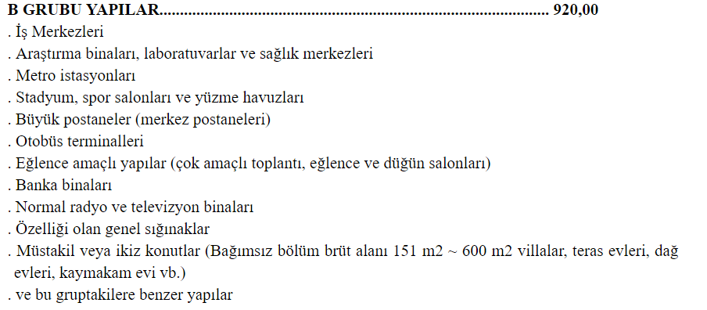

Figure 32: Ministry of Environment and Urban Planning

Table 28: Approximate Cost Estimation for Marmaray Feneryolu Station

|  |  |  |
| --- | --- | --- |
|  | **m**2 | **Cost** |
| Platform Area | 2167 | TRY 1,993,640.00 |
| Concourse Area | 3308 | TRY 3,043,360.00 |
| Roof Area | 3587 | TRY 3,300,040.00 |
|  | Total | TRY 8,337,040.00 |

It is important to point out that this cost is just an approximate value. The real cost of the project might be higher.

# REFERENCES

Birand,A., Ergun, U., & Erol, O. (2011). *CE366 Foundation Engineering 1 Lecture Notes.*

Carter, M., & Bentley, S. P. (1991). *Correlations of Soil Properties*. London: PENTECH PRESS.

CE363 Lecture Notes.

CE464 Lecture Notes.

*DESIGN AND CONSTRUCTION SPECIFICATIONS FOR STEEL STRUCTURES by MINISTIRY OF ENVIORENMENT AND URBAN PLANNING (September, 2016).*

Ersoy, U., Özcebe, G., & Tankut, T. *Reinforced Concrete*. Ankara: METU Press.

*TS498-DESIGN LOADS FOR BUILDING.*

*TS500-REQUIREMENTS FOR DESIGN AND CONSTRUCTION OF REINFORCED CONCRETE STRUCTURES*.

*TSC2007-TURKISH SEISMIC CODE.*

# APPENDICES